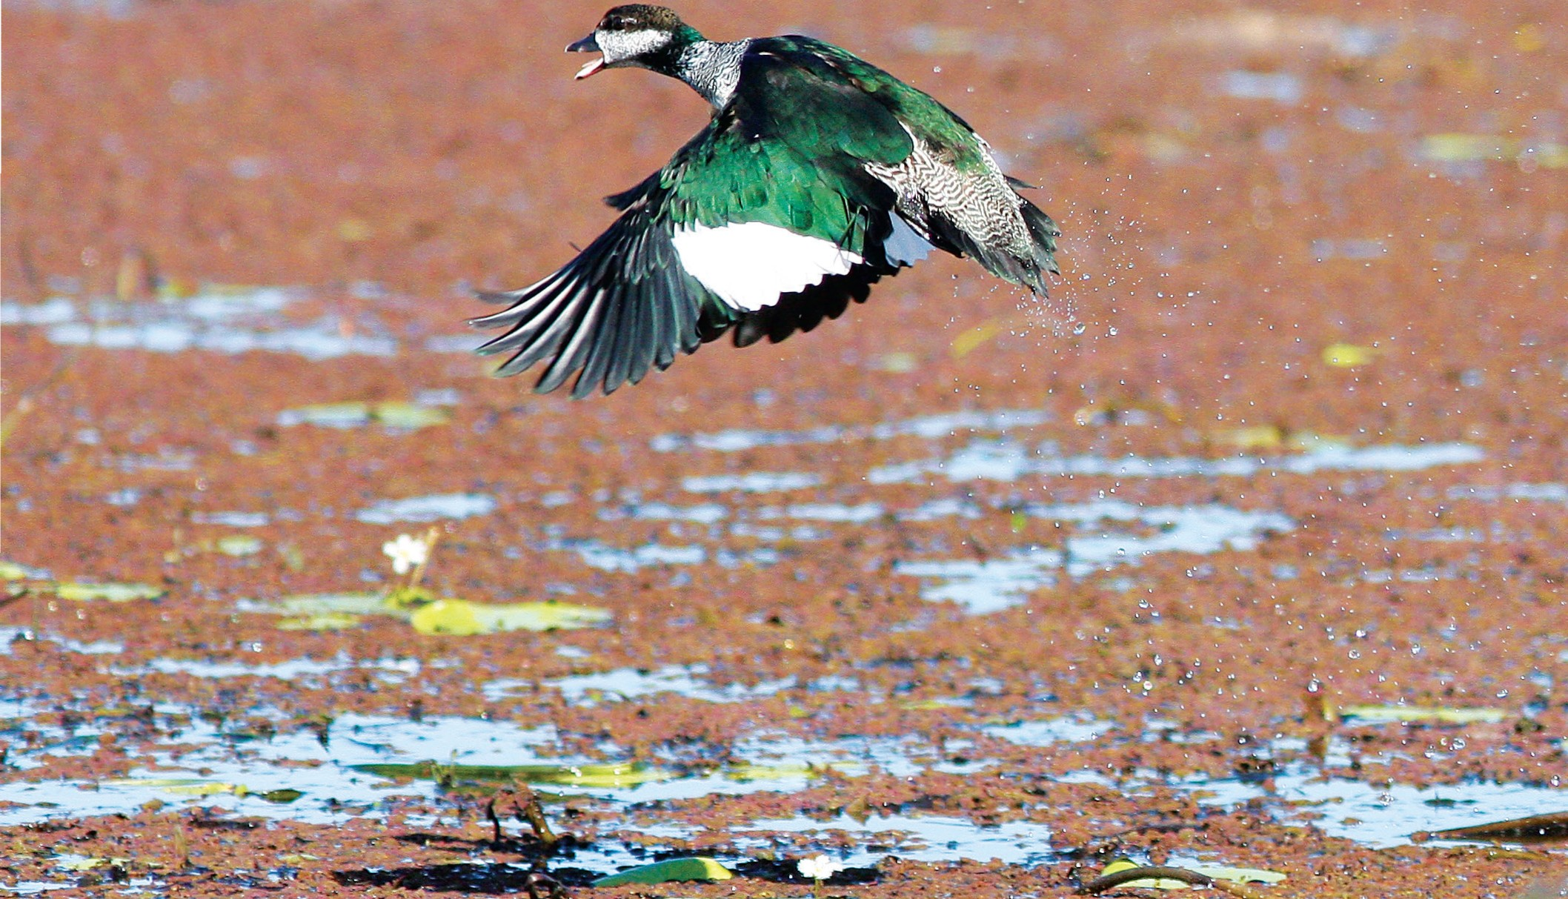
I age Courtesy o tY!otony.bl •• •• •

Green Pygmy-Goose


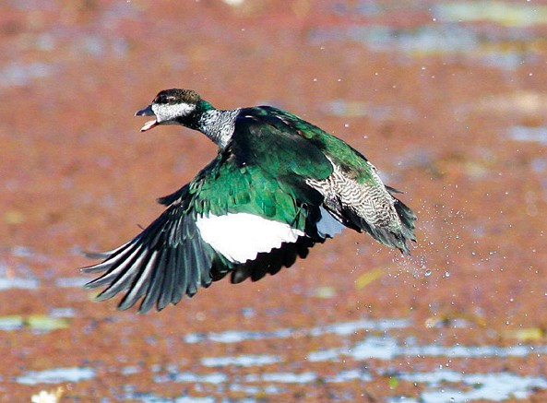
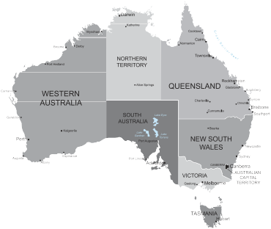
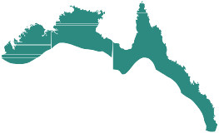

Fast Facts

Scientific Name: Nettapus pulchellus Other Name:

Size:
33cm

Weight:
300g

Gestation/Incubation:
24-30 days

Number of young/eggs:
8-12 eggs

Conservation Status

Extinct
Extinct in the Wild Critically Endangered Endangered Vulnerable
Near– Threatened
Secure

Did You Know?

- Green Pygmy- Geese are on the smallest water fowl in the world.
- Rarely comes out of the water onto land or to perch in trees.
Description
Male and female have different coloured neck and heads. Males have a green neck and conspicuous white cheeks. The Female has a dark band down the back of the neck but the rest of the neck is white. Both are iridescent green on the back.

Diet
The Green Pygmy Goose feeds almost exclusively on aquatic vegetation. Floats on water surface grazing on buds and plants. Will dive to 1/2 a metre to reach submerged plants.

Distribution
Found in coastal North Australia from Broome down to Fraser Island. Will sometimes travel into Northern New South Wales. Will move about in its range depending on seasonality. Inhabits tropical lagoons and lakes that support water lilies and other floating vegetation.

Threats
The population is highly dependant on seeds and flowers of water lilies but is currently stable across most of its range. Destruction of aquatic vegetation by cattle in Western Australia have been blamed for local decline of this species.

Life Cycle
Breeding takes place December to March with the nest usually in tree hollow or near water. The male will find several nest sites but the female will have the final decision. They are thought to mate for life.

Location in TYTO Wetlands/Parklands
Best spot to see is Wetlands Main Lagoon and Lagoon closest to Information Centre most months.

